MODULE 4 – INTRODUCTION TO DBMS

LAB EXERCISES

3. SQL Constraints
Lab 1.
Create a table teachers with the following columns – teacher_id (primary key), teacher_name (not null) and email (unique).
Ans.
1. CREATE TABLE teachers(teacher_id int PRIMARY KEY AUTO_INCREMENT, teacher_name varchar(255) NOT NULL, subject varchar(255) NOT NULL, email varchar(255) UNIQUE);
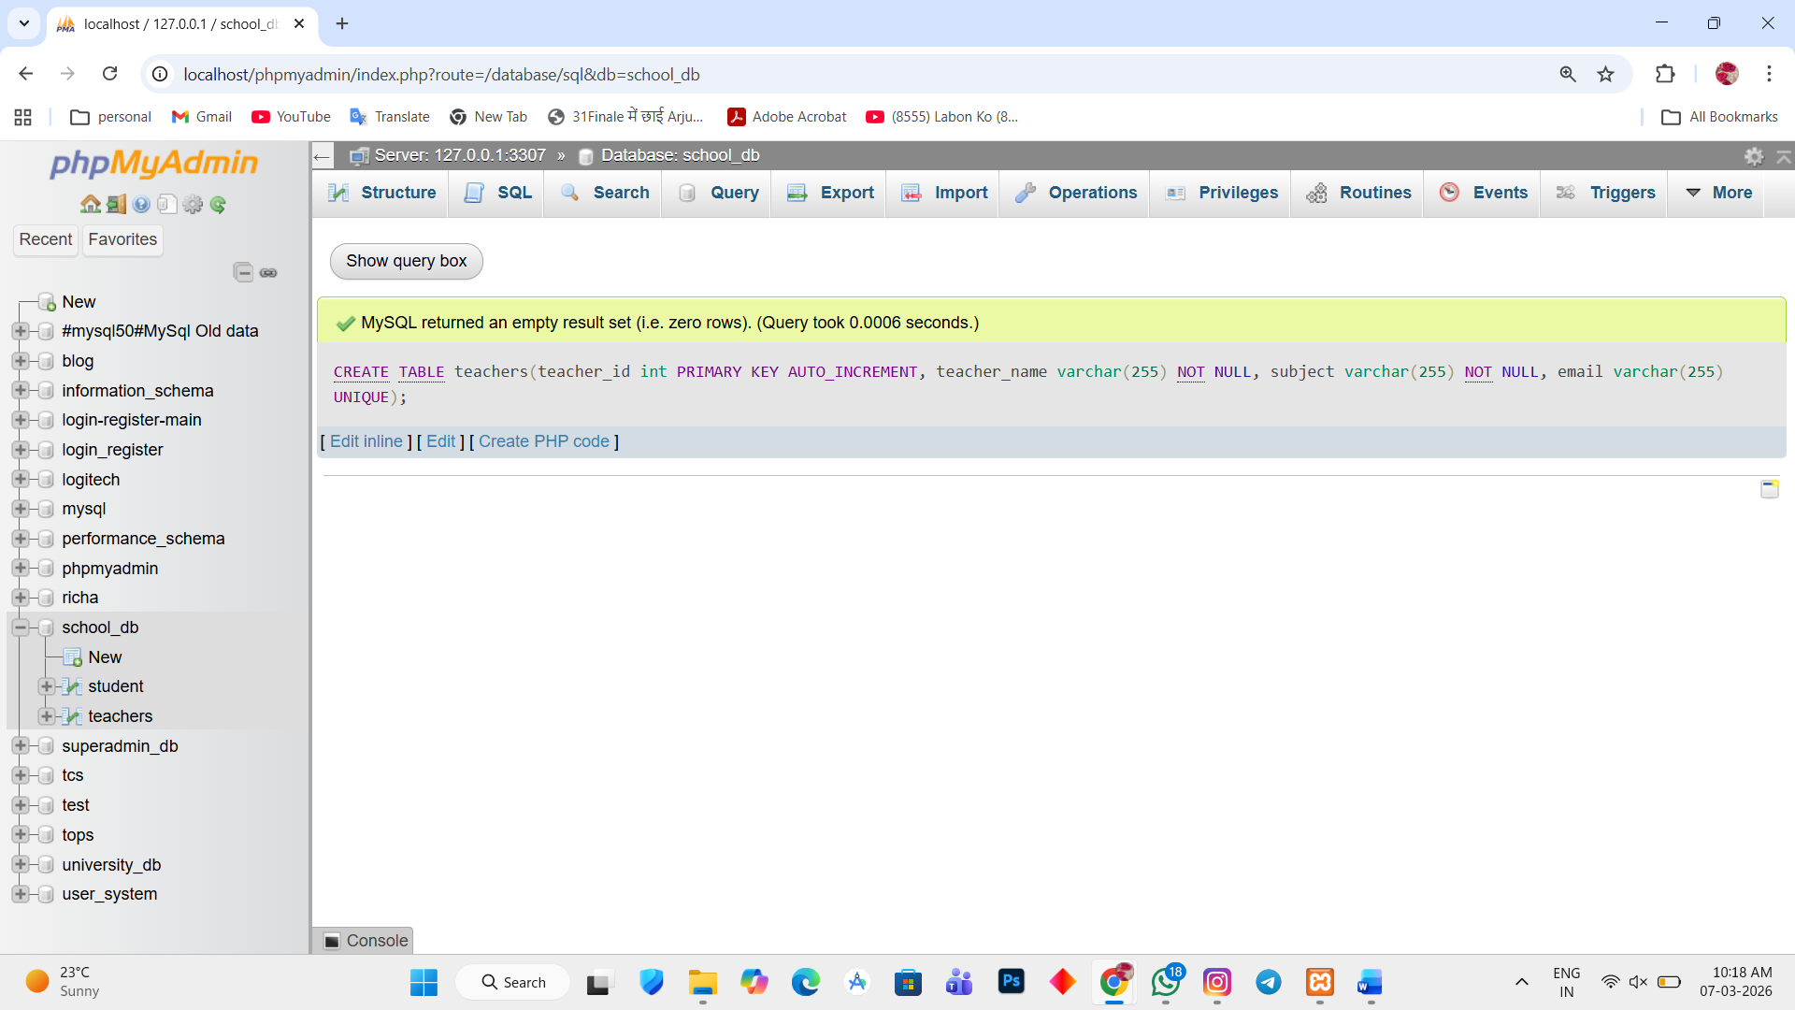

Lab 2.
Implement a foreign key constraint to relate the teacher_id from the teachers table with the students table.
Ans.
1. ALTER TABLE student ADD teacher_id int;
